**RLCP Citizen Science Continuous Stream Discharge Monitoring Update Jan 2023**

All sampling equipment and installation materials required for continuous monitoring of stream discharge were obtained near the start of the year, including the HOBO U20L level logger, HOBO data shuttle, Kestrel atmospheric pressure logger, and GeoPacks handheld flow meter. A volunteer constructed a protective PVC housing (see Figure 1-2) for the HOBO level logger according to the schematics in [Fogg et al. (2020)](https://doi.org/10.1111/2041-210X.13367). Several RLCP board members/trustees first attempted to install the HOBO level logger at Sheepwash Bridge (TL80696 61762), Ickworth Estate on 19 Jan using the methods detailed by [Fogg et al. (2020)](https://doi.org/10.1111/2041-210X.13367), but could not reach the bottom of the bridge footing with a 300 mm drill bit due to high winter water levels. On 28 Jan, volunteers attempted to install an eye plate to the bottom of a brick footing of Sheepwash Bridge, on the upstream-facing side, using marine epoxy (cf. Isaak et al. 2013). RLCP volunteers will return during the first week of Feb to determine if the eye plate is securely fastened, as this is outside the expected curing period for the epoxy, and more epoxy will be applied if needed prior to attaching the HOBO level logger and housing using a quicklink as shown in Figure 1. The Kestrel atmospheric pressure logger was installed in a tree (see Figure 3) just downstream of Sheepwash Bridge concurrent with the eye plate installation attempt. The tree limb is flagged with a reflective pink band, as the logger is very inconspicuous and could be difficult for subsequent volunteer teams to locate.

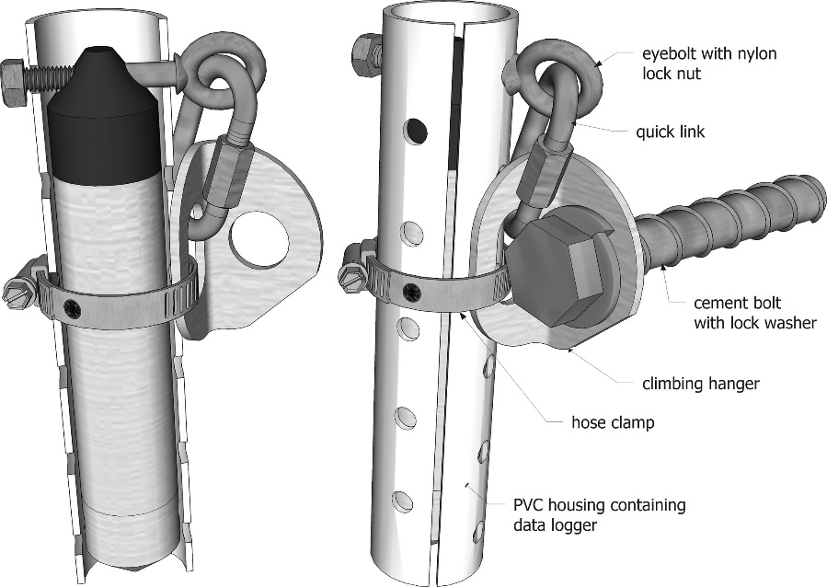

Figure 1 Diagram of the protective housing for a HOBO water level logger installed on a rock-like surface within a streambed, from Fogg et al. 2020.

Figure RLCP-owned HOBO U20L in volunteer-created PVC protective housing similar to Figure 2 schematic..

Figure The RLCP Kestrel logger (circled) is hung from a tree a few meters downstream of Sheepwash Bridge to provide measurements for atmospheric pressure compensation of the HOBO U20L level logger measurements.

The Geopacks flow meter will be used by volunteers to periodically measure stream cross-sectional velocity over spring and summer whilst the Linnet’s water level is expected to slowly recedes. This will allow RLCP to create a stage-discharge relationship with the measurements from the HOBO level logger. Volunteer training dates have not been determined, but are expected to occur in Feb or early Mar. Volunteer teams of 2-3 will be supervised by the trainer for initial surveys to ensure the gauging protocol is followed correctly.

**References**

Fogg SK, O'Daniel SJ, Poole GC, Reinhold AM, Hyman AA. 2020. A simple, reliable method for long-term, in-stream data logger installation using rock-climbing hardware. M Eco Evol 11(5):6. https://doi.org/10.1111/2041-210X.13367

Isaak DJ, Horan DL, Wollrab, SP. 2013. A simple protocol using underwater epoxy to install annual temperature monitoring sites in rivers and streams. Gen Tech Rep RMRS-GTR-314. Fort Collins (CO): U.S. Department of Agriculture, Forest Service, Rocky Mountain Research Station.